**Curse Blade**

**Cezar-Alexandru Javad**

**Duy Huu Nguyen**

**Yifan Chang**

**Group E**

**Git repository URL: <https://github.com/DuyNguyen19993010/Game-module.git>**

**Gameplay video URL:**

**Concept: Concisely describe the high-level concept of the game (200 words max.):**

Cursed Blade is a 2D hack’n’slash platformer that accentuates the melee combat. The story of the game takes place in an old Era in Japan. In this era a new king takes the throne, a king that makes the lives of the peasants very harsh. The main character represents a skilled samurai that aims to save the kingdom by defeating the king and his generals. The player has the ability to dash, dodge, perform skills, perform combos and to wall-slide. All of those abilities are created in order to make the game more attractive for all the potential players. The game contains multiple types of enemies and bosses, all of them having different stats (attack and HP), a different behaviour and different abilities (for example spawning fire balls). Other features allow the player to upgrade his stats points, to use various items, and to recruit allies that can help him during the journey. Our goal is to create a game that is attractive in different ways, not only with the combination of features but also with the art style and level design.

How to Play: Basic instructions, including which scene should be run first (100 words max.).

Controls:

A,D: to move into left or right direction.

Space: jump.

Left Shift:Dash.

A or D: while in the air and close to a wall to wall climb

Space + A or D while on wall:to do a wall jump

K: to attack, or double K in order to perform a combo.

Jump + L: Air attack.

C: call the first ally.

V : call the second ally.

S+K : perform fire skill.

L on the ground: perform moon skill.

R:press when spirit bar is full to go into rage mode

P on the ground:press at the right time trigger the counter attack otherwise player receives damage

N: talk to NPC.

Tab: Open the inventory

Esc: Call the Menu options

E: Navigate through items

F: Use current item

Tab: In order to press the buttons in the menu.

Scene order to player:

In the Material folder:there are 3 scenes MainMenu, Scene and RespawnScene

The MainMenu scene must be play first and then no further scene is required to be clicked on because the scene will be transitioned by the game logic.

Feature List:

Player systems and features:

* Dashing: this feature allows the player to dash instantly for a long distance. This ability can be used during dangerous situations where the player is very low HP and he needs to retreat, or in order to jump over long obstacles.

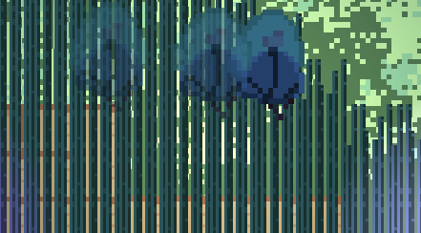

* Skills: Player can use two types of attack skills. One is a fire skill and the other one is a moon Skill. The fire skill is used to perform an upward fire attack and the moon skill us used to make the main character spin and damage all the enemies around him.
* Parrying: Player can parry an attack. If the parrying ability is used at the right time and the player successfully parries, the main character will also counter-attack and damage the enemy.
* Ally system: The player can call the allies he unlocked during the journey. When an ally is called, it will get spawned and it will perform a certain action depending on the ally chosen. The first ally will explode once is spawned and damage all the enemies around the explosion, and the other ally will find an enemy, charge to it, and then explode.

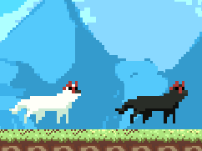

* Spirit system: This system allows the player to increase his damage by 3 damage . While in spirit mode the player will regenerate his HP every second.

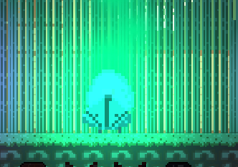

* Upgrade system: The player will be able to upgrade his item and stats using the upgrade station in the inventory menu. The player can upgrade their attack damage ,attack speed,Item maximum amount.
* Inventory System: The player can use his inventory for upgrading. There are 3 types of items: Fortune pouch :can heal the player,Crimson ashes: can make the player immune to damage for 5 seconds and the last item can be used in order to teleport the main character back to the last checkpoint.

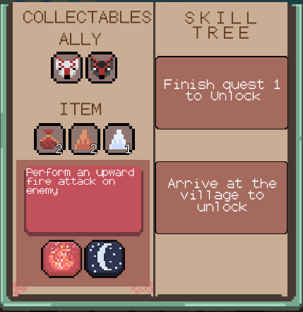

* The NPC System: This system allows the player to talk to the available NPC’s and it can be used for unlocking the allies, and also for the story development.
* Wall Slide: The player can perform a wall slide by jumping towards a wall. With the wall slide, the player can stick to the wall.

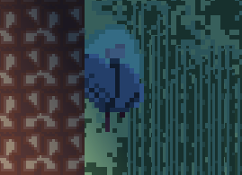

Enemies:

* Regular Enemies: There are various enemies implemented in the game. Each enemy acts in a different way. For example, there are enemies that follows the player and attack with the sword or enemies that throw bombs or fire balls to the player etc.

Some of the enemies:

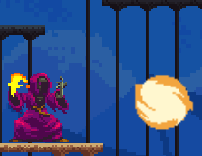 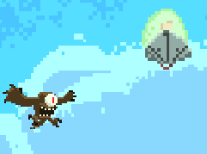

* Bosses: There are also bosses added to the game such as fire Boss and Moon Boss. Both of them have different attacking patterns which can be observed, and used to defeat the bosses easier.

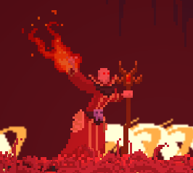 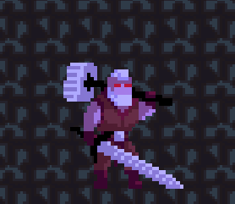

Non-Gameplay:

* Main-Menu: The main menu is what the player sees the first time when they enter the game. It has 3 options: Start, Continue and Exit. Start is used to start a new game, Continue is used to load a previously saved game and exit is used to exit the game.

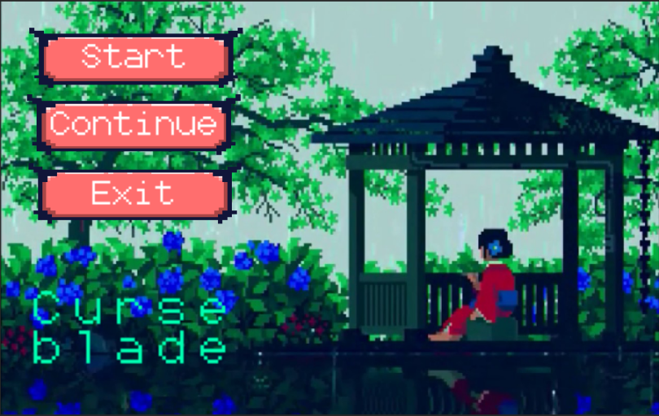

* In-game Menu: This menu can be accessed while in game by pressing the ESC key. It has 4 options: continue (to resume the game), Save (to save the current progress), Check Point (load the previous check point) and exit (to exit the game).

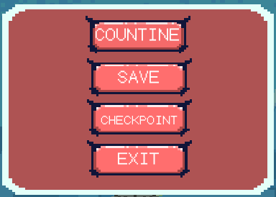

* Save and Load Features: These features are used to save the current progress of the game. The player can save the current progress by pressing “Save” in the in-game-menu and this will save the last check point player’s progress and be later loaded also from the menu. There are multiple checkpoints across the levels.Once a checkpoint is reached, if the player dies without saving first they will respawn at the last checkpoint and will have all of their progress up to that point saved.

Checkpoint totem:

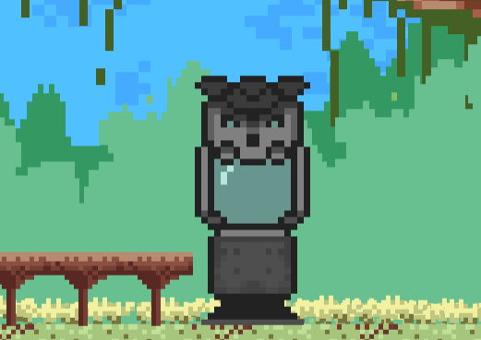

Audio-Visual:

* BGM system: This is an audio system that is used to add background music to a room. It is designed in such a way that each room can have different background music.
* Character-Audio: This is an audio system that lets the character have sounds for different actions such as walking, jumping or attacking. It is designed in such a way that it can implement a multiple sounds for the same action, or only one chosen sound.
* Lightning(Universal pipeline): is used to enchant the all the visual elements of the game, giving the game a more attractive look for a better experience.
* Visual: Most of the visual elements (with some exceptions) such as background images, sprites and animations are created by one of our group member (Duy Huu Nguyen).Other visual has been properly referenced in the readme.md on git.